**Lab 9**

**Objectives**

The objective of this lab is to understand and implement discrete event simulation using GPSS (General Purpose Simulation System) by modeling real-world systems such as service and inspection processes. Through the barber shop simulation, the goal is to analyze customer flow and service time over a defined period using arrival and service time distributions. The machine shop problems aim to simulate part production and inspection, incorporating randomness in processing and rejection, while demonstrating the use of both storage and facility constructs in GPSS. These exercises help in understanding queueing, resource allocation, and probabilistic decision-making in simulation.

**Q.1. Write a GPSS program to simulate a barber shop for a day (10 am to 5 pm) where a customer enters the shop every 10±3 minutes and a barber takes 4±2 for a haircut.**

**Source code:**

GENERATE 600,180

SEIZE BARBER

ADVANCE 240,120

RELEASE BARBER

TERMINATE 1

START 25200

**Output:**

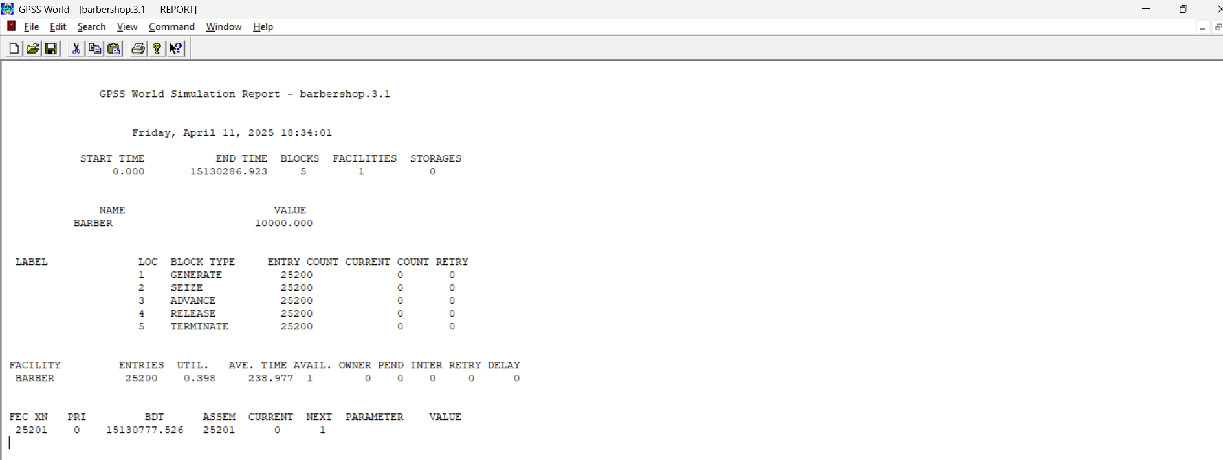

**Q.2. A machine tool in a manufacturing shop is turning out parts at the rate of one every 5 minutes. As they are finished, the parts go to an inspector who takes 4±3 minutes to examine each one and rejects 10% of the parts. Write GPSS program for 1000 parts.**

**Source Code:**

SIMULATE

GENERATE 300

ADVANCE 240,180

TRANSFER .1, REJECTED

TERMINATE 1

REJECTED TERMINATE 0

START 1000

**Output:**

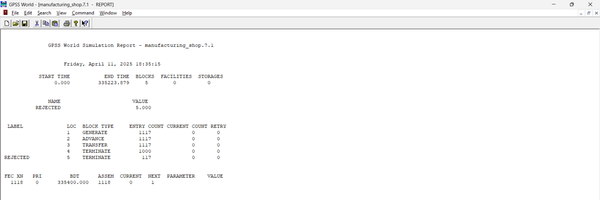

**Q.3. Implement Q. No. 2 using facility.**

**Source code:**

GENERATE 5,,,1000

SEIZE INSPECTOR

ADVANCE 4,3

RELEASE INSPECTOR

TRANSFER .1, REJECT

TERMINATE 1

REJECT TERMINATE 1

INSPECTOR STORAGE 1

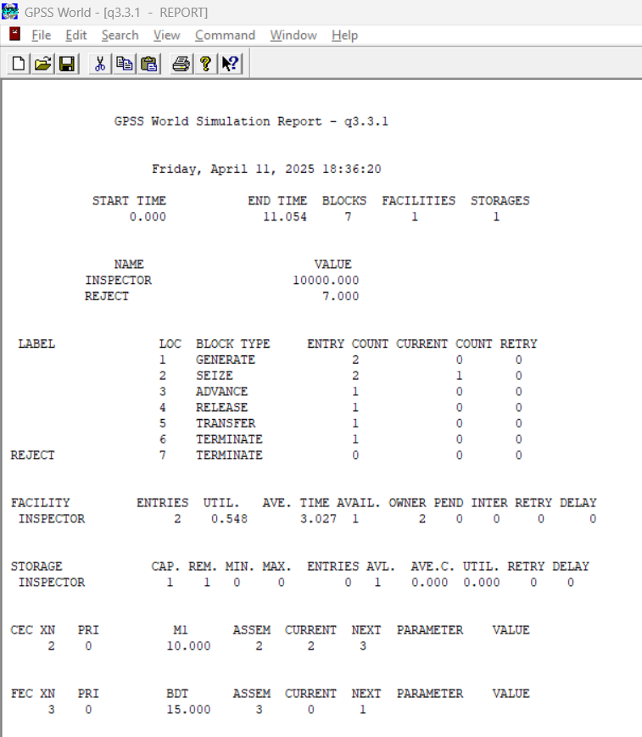**Output:**

**Q.4. A machine tool in a manufacturing shop is turning out parts at the rate of every 5 minutes. When they are finished, the parts are sent to an inspector, who takes 4±3 minutes to examine each one and rejects 15% of the parts. Write a GPSS program to simulate using the concept of facility.**

**Source code:**

GENERATE 5,,,1000

SEIZE INSPECTOR

ADVANCE 4,3

RELEASE INSPECTOR

TRANSFER .15, REJECT

TERMINATE 1

REJECT TERMINATE 1

INSPECTOR STORAGE 1

**Output:**

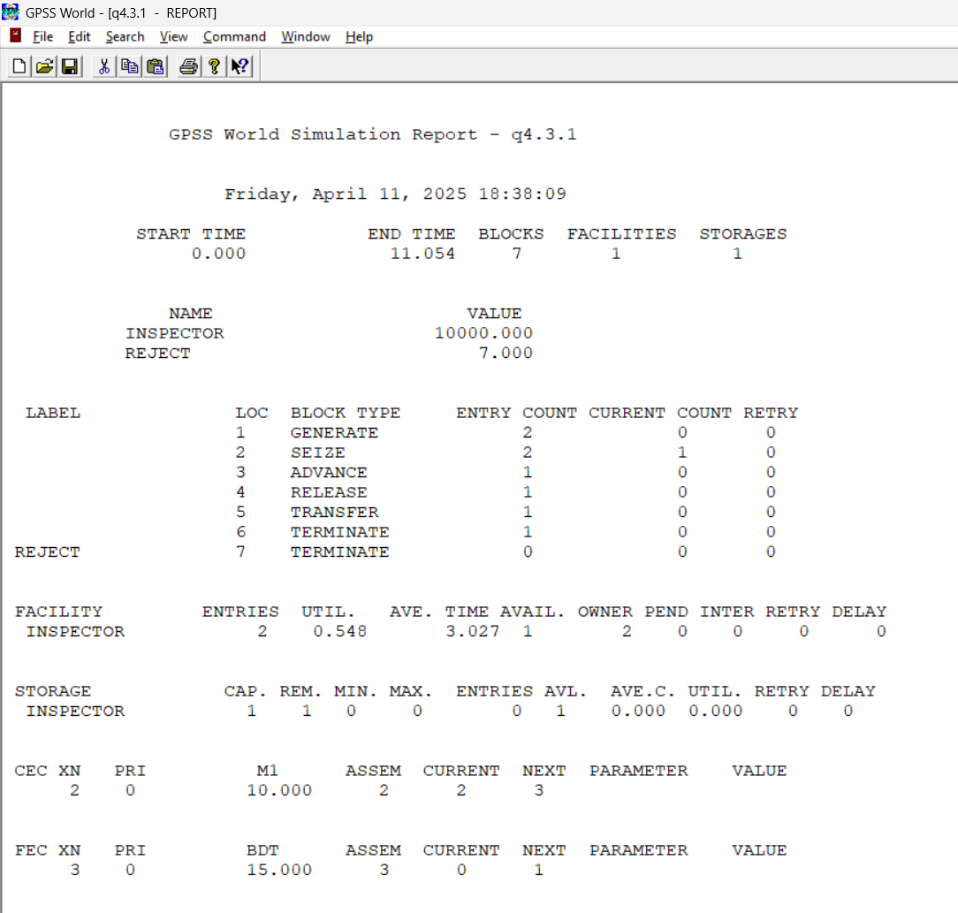

**Conclusion:**

In conclusion, the GPSS simulations provided valuable insights into modeling real-world service and manufacturing systems through discrete event simulation. By simulating scenarios like barber shop operations and manufacturing inspections, we were able to observe the impact of arrival rates, service times, resource constraints, and rejection probabilities on system performance. The use of facilities and storage elements in GPSS allowed us to represent and manage limited resources effectively. Overall, these simulations enhanced our understanding of queueing behavior, system efficiency, and the importance of accurate modeling in decision-making and process optimization.